**Leader Overview**

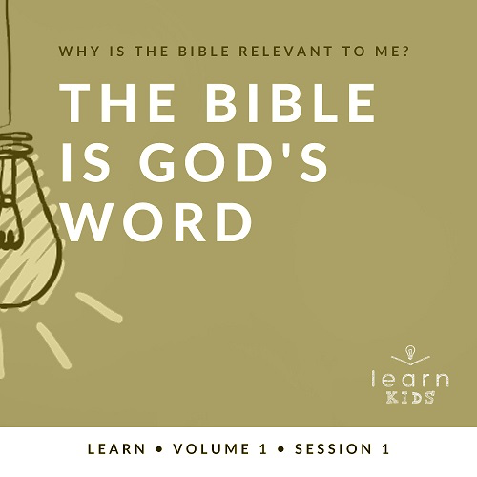

**Why is the Bible relevant to me?**

*Our upbringing often influences our view of the Bible. In your home, was the Bible a dust-covered book that you thought kept people from having any fun? Was it honored as the living, breathing Word of God? Or did your childhood view of God’s Word fall somewhere in between? In this* **Learn** *volume, we want kids to know that God speaks through His Word to those who will listen, giving guidance and correction for their lives (*[*2 Timothy 3:16–17*](https://ref.ly/logosref/Bible.2Ti3.16-17)*).*

**The Bible Is God’s Word**

*When we read the Bible, we’re mostly reading accounts of people’s interactions with God through history. Although people wrote down the words, God inspired them to write. God doesn’t make mistakes, so we can trust and follow the words that they wrote. This is exemplified in our Bible story. People were inspired by God to write about the coming Messiah (Jesus). Many years later, others were inspired by God to write down stories of how Jesus fulfilled all those prophecies written about the Messiah.*

**Bible Lesson**

Jesus Is Prophesied About

[Isaiah 7:14](https://ref.ly/logosref/Bible.Is7.14); [Luke 1:26–38](https://ref.ly/logosref/Bible.Lk1.26-38)

**Faith Fact**

I will trust God’s Word.

**Faith Verse**

[2 Timothy 3:16](https://ref.ly/logosref/Bible.2Ti3.16) (NLT)

All Scripture is inspired by God and is useful to teach us what is true.

**Preparing for the Session**

**Leader Preparation Time: 20–25 Minutes**

|  |
| --- |
| ***You Will Need***  ***Large Group***   * *Personal study Bible with highlights and notes* * *Worship songs (Song suggestions: “Who You Say I Am” by Hillsong Worship; “Goodness of God” by Bethel Music; “Headlight” by Elevation Youth; “Breakthrough” by Elevation)* * *For groups not using a phone or tablet only, add:*   *• Projector or TV*  *• Laptop*  *•* ***Countdown60 Video****–60 seconds*  *•* ***Faith Fact Slide***  *•* ***Faith Verse Video*** *or* ***Slide***  *•* ***Bible Lesson Video***  *•* ***Teaching Point Slides 1–3***  *• Large eraser*  *•* ***Large Group Prayer Response Page****, enough copies so each kid can have   one verse*  ***Small Group***   * *Bibles, one per kid (preferably all the same version)* * *“Books of the Bible” song from JumpStart3* * ***Small Group Faith Verse Review****, one bookmark per kid* * *Markers* * ***Small Group Activity Page****, one per kid* * *Pencils, one per kid*   *To download session videos, slides, and printables, visit:* [*BibleEngagementProject.com/downloads*](https://bibleengagementproject.com/Downloads) |
| ***Getting Ready***  ***Large Group***   * *Download videos and slides if needed.* * *Select worship song(s) and have them ready to play.* * *Print copies of the* ***Prayer Response Page****. Cut apart the verses on the page, so each kid receives one verse.*   ***Small Group***   * *Print copies of the* ***Small Group Activity Page****, one per kid.* * *Print copies of the* ***Faith Verse Review Page****, one copy per three kids. Print the bookmarks front to back. Cut apart the bookmarks.*   ***First time leading* Learn *for Kids? Check out the*** [***Facilitator Guide***](https://0b769b0ed3569ef9d18b-f88d8272f61086866d50d048b43ef630.ssl.cf2.rackcdn.com/sites/biblengagementproject/Listen_Facilitator_Guide.pdf)***.*** |

**Large Group**

**30 Minutes**

*See what’s needed at the beginning of the session.*

**Introduction**

I’m so glad you’ve joined me today. For the next few sessions, we’ll be focusing entirely on God and His Word. What’s another name for God’s Word? *(Group response)* You might be thinking that we always focus on the Bible, and we do. But, we’re taking a deeper look at what God’s Word really is and why it matters to our life today.

The Bible is a super old book that was written by a group of about forty authors thousands of years ago. Why does an old book written thousands of years ago matter to us? Well, it matters because it’s the inspired Word of God. What do you think I mean by that? *(Allow responses.)*

God chose the writers of the Bible. He even helped them with the words they wrote. He used these writers to bring His words to all of us! If we trust that God is who He says He is, we can also trust His Word.

**Faith Fact**

That’s what our Faith Fact for today says: **I will trust God’s Word**.

• *Show the* ***Faith Fact Slide.***

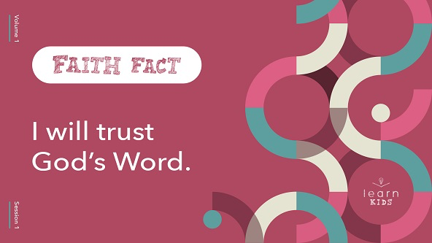

Say it with me as loudly as you can. **I will trust God’s Word.** Now whisper it quietly. *(Group response)* Shout it again. *(Group response)* Great job!

**Game**

**Mirror Effect**

|  |
| --- |
| ***You Will Need***   * ***Countdown60 Video****–60 seconds*   *No prep needed for this activity.* |

As Christians, we believe and trust in God’s Word. We know that we can listen to what it says and follow the instructions inside it because they are from God. When you trust someone, like a parent or a friend, you’re willing to follow what they say and do. Choose a friend to play this game.

• *Allow the kids to choose their partner. If you have an extra kid, partner them with a leader.*

Okay, here’s what you need to do. You’re going to work together to follow each other’s every move. Face your partner and choose who will be the leader first. The leader decides the actions to do. The partner must mirror every action the leader does for one minute. Then, you’ll switch places.

• *Play* ***Countdown60 Video****.*



• *Play until time is up. Then have the kids switch places and repeat.*

How did your partner do as leader? Wave your hands up high if they did a good job. *(Group response)* How did they do as follower? Give me two thumbs-up if they did a good job. *(Group response)* I trust you chose the right partner and worked together well. The very best partner we can choose is God. We can always trust and follow Him by knowing His Word.

**Worship**

God also loves it when we spend time worshipping Him. One way to worship God is by singing. Let’s do that together now.

• *Lead the kids in singing one or two praise songs. See suggestions at the beginning of the session.*

**Bible Lesson**

I really enjoyed worshipping God with all of you. Now, let’s pull out our Bibles and learn more about God’s Word together. Remember, people wrote down the words of the Bible, but God inspired them with what to say.

For example, God gave people, called prophets, information about Jesus hundreds of years before Jesus was born. That’s like God giving you information about your great-great-great-great-great-great-great, great-grandchild. What if this information included his or her name or all kinds of other things? That would be amazing, wouldn’t it? *(Group response)*

That’s exactly what God did with Jesus. The information the prophets wrote about Jesus in the Old Testament is known as prophecies. A prophecy is often something that God says will happen in the future. When Jesus came to earth, He fulfilled the prophecies that were written about Him in the Old Testament. We’re going to read one of those prophecies and learn how Jesus fulfilled it in today’s Bible story. But first, let’s pray together.

**Prayer**

|  |
| --- |
| *Dear God, thank You for giving us Your Word to read and learn from. Help us to fully trust in You and Your Word. Amen.* |

**Video Intro**

Before we look at the Bible story, let’s watch this video.

• *Play* ***Bible Lesson Video****.*

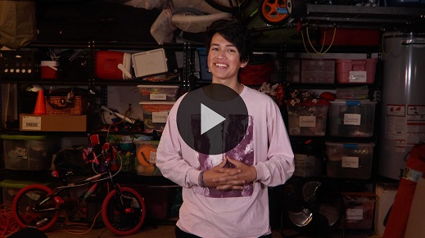

**Bible Story**

**Jesus Is Prophesied About**

Have you ever heard someone predict that something would happen and then it came true? *(Allow responses.)* Maybe they predicted the weather using science or predicted you would slip because they threw out a banana peel. Well, what the Old Testament prophets did was different from that. They wrote down things God told them about the future Messiah—Jesus. Everything they said about Him came true because God told the prophet what to write. Let’s read our Bible story and learn more about a very important prophecy about Jesus.

Open your Bible or pull up a Bible app on your device. Open it to [Isaiah 7:14](https://ref.ly/logosref/Bible.Is7.14).

• *Read* [*Isaiah 7:14*](https://ref.ly/logosref/Bible.Is7.14) *aloud to the group.*

• *In order to keep Large Group time moving along, we don’t recommend having the kids read.*

The verse we just read was written hundreds of years before Jesus was born. Now, let’s read about Jesus from the New Testament. Turn to [Luke 1:26–38](https://ref.ly/logosref/Bible.Lk1.26-38)***.***

• *Read* [*Luke 1:26–38*](https://ref.ly/logosref/Bible.Lk1.26-38) *aloud to the group.*

**Teaching Time**

|  |
| --- |
| **You Will Need**   * Large eraser * Personal study Bible with highlights and notes   **Getting Ready**   * Be prepared to share a funny story of a small mistake you have made that the kids can relate to. * Be prepared to share the brief history of your personal study Bible. |

How amazing is it that God gave the prophets special details about Jesus coming to earth? Then, the prophets included these details when they wrote the Old Testament. They never could have guessed all those details correctly on their own. Only God knows everything that will happen in the future. Reading Old Testament prophecies that were fulfilled in the New Testament helps us believe that the Bible really is the inspired Word of God.

Do you remember our Faith Fact? *(Group response)* That’s right. **I will trust God’s Word.** Let’s say that together one more time.

• *Lead the kids in saying the Faith Fact again.*

If we’re going to trust God’s Word, then there are three important things we need to know about God’s Word.

**1.** **God’s Word was written by people but inspired by God.**

• *Show the* ***Teaching Point 1 Slide.***

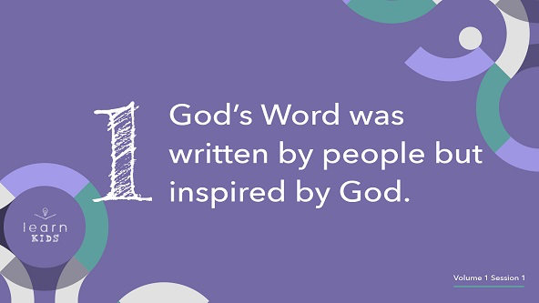

How could God’s Word be written by people? It’s really simple actually. God chose to allow certain individuals to be a part of writing the most important book ever. About forty people helped to write the Bible that we read today. God loves using ordinary people like you and me to do incredible things with His power behind them. Here’s how God gave us His Word.

God spoke to the writers. Kids, put your hands up to your mouth like you are creating your own megaphone. *(Group response)*

The writers listened to God’s words. Now, put your hands up to your ears like you are trying really hard to listen to someone. *(Group response)*

The writers wrote God’s words down. Kids, hold up your hand and pretend to write something in the air. *(Group response)*

It’s as simple as that. After many years of people copying those original writings and translating them into many different languages, all of us can read and study God’s Word now.

**2.** **God doesn’t make mistakes.**

• *Show the* ***Teaching Point 2 Slide.***

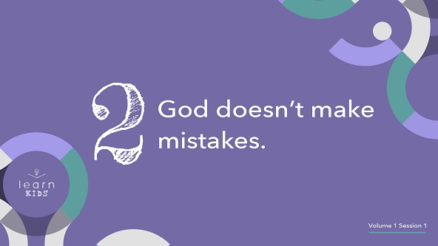

Do you make mistakes sometimes? *(Group response)* Do you think your parents make mistakes sometimes? *(Group response)* How about me? Do you think I make mistakes sometimes? *(Group response)* We all make mistakes sometimes because none of us is perfect.

• *Share a funny story of a small mistake you have made.*

Even though you, me, and every person makes mistakes, God never makes mistakes. So we can be sure that everything He says is correct and true. All the words He gave the Bible writers had zero mistakes.

• *Hold up the eraser.*

God didn’t need a big eraser to erase His mistakes. He doesn’t need us to erase anything from His Word either. It’s important that we believe and trust in all of God’s Word, not just the parts we like or agree with. If we believe that God is perfect and doesn’t make mistakes, then we must believe that His Word is 100 percent true, too.

**3.** **God’s Word is still for us today.**

• *Show the* ***Teaching Point 3 Slide.***

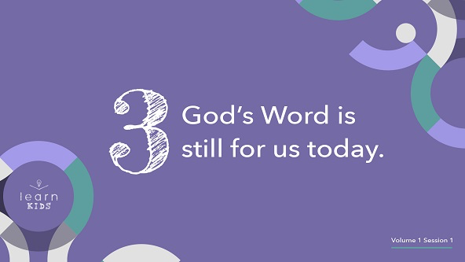

Knowing the Bible is God’s Word is only part of what’s important. We need to read it to know what it says. Think about how you like to read your Bible. Do you like to read a physical book or read it on a device? *(Allow responses.)* Would you rather listen while someone else reads the Bible to you? *(Allow responses.)*

We have so many options and ways to read God’s Word today. Your family might even own multiple Bibles and have many devices that you can read or listen to the Bible on. This is one of my Bibles that means a lot to me.

• *Hold up your personal study Bible.*

• *Let them see the notes and highlights inside if you have them.*

• *Explain who gave it to you and why the Bible means so much to you.*

• *Keep your Bible in your hands as you read the next section.*

The Bible has helped me so many times throughout my life. Did you know that the entire Bible wasn’t written at the same time? It wasn’t written as a big book from start to finish.

It’s incredible to think that first God had people write the Bible in separate parts. It took God and the writers more than a thousand years to write it. Back then people didn’t have the whole Bible at home, so they couldn’t choose to read whenever they wanted to. People would gather and listen as parts of the Bible were read to them. Then, they’d memorize large parts of Scripture.

The Bible is one of the oldest books ever. Did you know it wasn’t written in our language at the beginning? *(Group response)* The entire Bible has been translated into over seven hundred languages, including the one we speak. It’s the most read book in the world, and it has sold over 5 billion copies. That’s a lot of Bibles!

The Bible wasn’t just for people thousands of years ago. God inspired it for all of us. God wants us to spend time reading it every day. If you want to know God better, spend time reading His Word. It’s ready and available to you thanks to all the people that God used to give us the Bible.

**Prayer and Response**

*Consider playing a worship song softly in the background while kids pray.*

|  |
| --- |
| ***You Will Need***   * ***Large Group Prayer Response Page****, enough copies so each kid has one verse*   ***Getting Ready***   * *Print copies of the* ***Prayer Response Page****. Cut apart the verses on the page, so each kid receives one verse.* |

Think about this for a moment. When was the last time you spent time reading and thinking about God’s Word? Sometimes I get busy, and I forget to read the Bible. Sometimes I do my devotions quickly because I’m in a hurry instead of taking time to think about what I’m reading. I sometimes don’t take the time to listen to what God wants to say to me.

God wants to spend time with us. He wants to talk to us through His Word. Let’s pray and ask God to speak to us through His Word right now. I have some slips of paper that have different verses written on them. You’re going to get a Scripture verse to read to yourself. Let me know if you need help reading any of the words.

• *Give a Scripture verse to each kid. Help younger kids read their verse.*

Now, let’s pray and ask God to speak to us through these verses. Then, we’ll pause and listen quietly for a few moments.

**Prayer**

• *Optional: Have the kids repeat phrases of the prayer after you.*

|  |
| --- |
| Dear God, thank You for giving us Your inspired Word. We want to hear from You through it. Amen. |

• *Pause for a couple of minutes for kids to meditate on their verse.*

• *Optional: Consider allowing kids to share with the group how their Scripture applies to their lives.*

Every time we read God’s Word we should ask God to talk to us through His Word. He doesn’t always speak to us right away, so we should keep reading and listening.

• *Allow kids to take these home with them to pray and review.*

**Faith Verse**

Our Faith Verse reminds us of why God’s Word is so important to our lives. Let’s learn it now.

• *Play* ***Faith Verse Video****.*

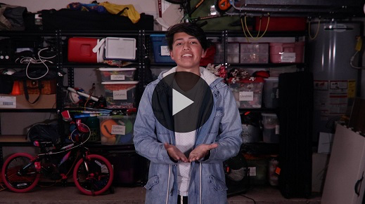

[2 Timothy 3:16](https://ref.ly/logosref/Bible.2Ti3.16) (NLT)

All Scripture is inspired by God and is useful to teach us what is true.

**Faith Fact**

We can trust what we read in the Bible because we believe that the words are inspired by God himself. Our Faith Fact reminds us of that.

• *Show the* ***Faith Fact Slide****.*



Say the Faith Fact with me one more time. **I will trust God’s Word.** I hope that you really do trust God and His Word. Let’s go to Small Group time and learn even more about the Bible.

• *Dismiss kids to Small Group time or to go home if your group time ends here.*

**Small Group**

**30+ Minutes**

*This section can be done in conjunction with the large group or on its own if you do small groups with your kids. During Small Group time, the goal is to connect the kids with the Word of God and to each other. All activities are led by the small group leader.*

**Group Connection**

**Do You Trust Me?**

Who do you trust the most in your life? *(Allow responses.)* We all have people we would trust with anything—our parents and grandparents, teachers, our pastors.

How does someone earn your trust? *(Allow responses.)* People usually earn my trust by spending time with me. Then, we get to know each other well.

We’re going to play a game and see who we can trust in our group. Each of us will share a statement about ourselves. Then, we’ll ask, “Do you trust me?” Here’s the catch. What you share might be true or false. Everyone else in the group will decide if they trust your word or not. I’ll go first.

• *Share a statement about yourself. It will be more fun if it’s something that’s not true. Then, have kids guess if they trust you.*

• *Keep playing until everyone has had at least one turn sharing a statement about themselves.*

Was it easy or hard for you to tell who you could trust? *(Group response)* I’m glad we never have to ask that question about God. We know we can always trust Him and His Word.

**Learn about It**

|  |
| --- |
| ***You Will Need***   * *Bibles, one per kid (preferably all the same version)* * *“Books of the Bible” song from JumpStart3*   *No prep needed for this activity.* |

**Scripture Search:** [**2 Peter 1:20–21**](https://ref.ly/logosref/Bible.2Pe1.20-21)**;** [**Acts 17:11**](https://ref.ly/logosref/Bible.Ac17.11)**;** [**Romans 3:4**](https://ref.ly/logosref/Bible.Ro3.4)**;** [**1 Thessalonians 2:13**](https://ref.ly/logosref/Bible.1Th2.13)

Let’s dig deeper into God’s Word and see what else He has to say about trusting the Bible. As we find and read each of these verses, let’s consider:

How does this Scripture teach us about what God wants us to know about trusting His Word?

What does it mean for our life today?

• *Give each kid a Bible and search for one or more of the Scriptures as a group as time allows. When everyone has found the Scripture, have one of the kids read it. Then, answer the questions about it.*

• *Pair kids who need additional help with older kids or start simple and look up the session’s Bible story Scriptures:* [*Isaiah 7:14*](https://ref.ly/logosref/Bible.Is7.14)*;* [*Luke 1:26–38*](https://ref.ly/logosref/Bible.Lk1.26-38)*. Kids will get better at finding Scriptures the more they practice.*

• *Optional: Make this a competition to see who can find the Scripture first.*

**Bible Reading Tip**

Did you know that the Bible is one book that includes many different books? *(Group response)* You can see all the books of the Bible listed at the front of the Bible. Turn to the contents page. Let’s take a closer look.

• *Have kids turn to the table of contents page in their Bible.*

We don’t know who wrote every book of the Bible, but we do know that God inspired about forty people to write it. Some of the books begin by stating who wrote them. Some of the books are even named after the people who wrote them or who the book is about. Can you find any books that look like they might be named after the person who wrote it or who it is about?

• *Point out some of the books of the Bible to the kids.*

• *The first five books in the Old Testament were mostly written by Moses.*

• *Esther and Daniel were written during a time most Israelites were not in Israel.*

• *Matthew, Mark, Luke, and John are all books that tell about the life of Jesus on earth.*

• *Third John is the shortest book in the Bible.*

**Challenge**

Each time we’re going to have a challenge to do. Today’s challenge is to begin learning the names of all the books in the Bible in order. Let’s do that now.

• *Play the “Books of the Bible” song.*

During the week, turn to the list of books in your Bible and try to learn as many books as you can by next time.

**Faith Fact**

All of our Bible reading is a reminder to me of our Faith Fact. Say it with me: **I will trust God’s Word.**

**Group Discussion**

*Feel free to use all or just a few questions as a jumping-off place for good discussion. Questions marked with * are designed for more conversation. Adjust the questions based on the age or maturity of your group. Typically, older kids will be able to dive a little deeper than younger ones.*

**Questions**

• *If small group activities are not immediately following Large Group time, you may want to read the Bible story passage before this discussion.*

Do you trust everything you read on the Internet? Why or why not?

Do you trust that the Bible is God’s Word? Why or why not?

Do you believe that God makes mistakes? Why or why not?

* Do you make mistakes? Share a mistake you have made with the group.

* Have you ever read something in the Bible that you had a hard time believing? What was it? What makes it hard for you to believe?

* Why should we believe that God’s Word is still helpful for us today even though it’s a really old book?

* How can you help others trust in God’s Word?

**Prayer Requests**

*Finish group discussion by sharing prayer requests and praise reports. Keep track of your small group’s prayer requests and review them each time you meet.*

**Prayer**

*Have kids pray for each other’s prayer requests.*

**Faith Verse Review**

|  |
| --- |
| **You Will Need**   * **Small Group Faith Verse Review** bookmark, one per kid * Markers   **Getting Ready**   * Print copies of the **Faith Verse Review** **Page**, one copy per three kids. Print the bookmarks front to back. Cut apart the bookmarks. |

Our Faith Verse for today is [2 Timothy 3:16](https://ref.ly/logosref/Bible.2Ti3.16). It tells us why we can trust God’s Word. Let’s practice it now.

• *Show* ***Faith Verse Video****.*



[2 Timothy 3:16](https://ref.ly/logosref/Bible.2Ti3.16) (NLT)

All Scripture is inspired by God and is useful to teach us what is true.

Let’s make sure we’re familiar with the Faith Verse. Let’s say it as a group a couple more times. *(Group response)*

**Faith Verse Fun**

**Bible Bookmarks**

Because reading the Bible is so important, we’re going to make a Bible bookmark with our Faith Verse on it.

• *Give each kid a* ***Faith Verse Review*** *bookmark.*

Turn it over. What’s on the back? *(Group response)* Everyone will color a bookmark. When you’re done, you can take your bookmark home to help you remember both our Faith Verse and the books of the Bible. I hope everyone in our group will be able to say all of them.

• *Optional: Laminate the bookmarks for kids to use to mark the passages in future sessions.*

**Activity Page**

**Bible Book Word Search: New Testament**

|  |
| --- |
| ***You Will Need***   * ***Small Group Activity Page****, one per kid* * *Pencils, one per kid*   ***Getting Ready***   * *Print copies of the* ***Small Group Activity Page****, one per kid.* |

Our Activity Page will help us to learn the names of the books of the Bible. We’re starting with the New Testament books. Let’s see how many you can find. Make sure you cross them off as you find them.

• *Give each kid a copy of the* ***Small Group Activity Page*** *and a pencil. Let kids complete the word search.*

• *Optional: Play the “Books of the Bible” song as they search.*

**Dismissal**

Thanks for coming and learning more about God’s Word with me. I’m so glad we can trust the Bible. Let’s close in prayer.

**Prayer**

|  |
| --- |
| *Dear God, thank You for giving us Your Word. It was awesome to read prophecy about Jesus and then to see it fulfilled in Your Word. Help us trust what we read in Your Word. Amen.* |

**Faith Fact Recap**

• *Show the* ***Faith Fact Slide****.*



One important thing I want you to remember from today is our Faith Fact. Let’s say it together: **I will trust God’s Word.** I’m glad you came today. I can’t wait to see you next time**.**

• *Send home the* ***Activity Page, Prayer Response*** *verse slip****,*** *and* ***Faith Verse Review*** *bookmark****.***

• *Remind parents that there are* ***Family Devotions*** *available on the app to do with their kid.*

• *Tell everyone the date and time for the next session.*